Why model is necessary in MongoDB?

In MongoDB, documents are stored in a flexible, schema-less format. While this flexibility is powerful, it can lead to inconsistencies and challenges when managing complex data structures. **Mongoose models** provide a structured way to interact with MongoDB collections by enforcing schemas, ensuring data consistency, and offering various built-in features to simplify database operations.

Why Use Models in Mongoose or MongoDB?

1. Schema Enforcement:

MongoDB is schema-less, meaning it doesn't enforce a fixed structure for documents in a collection.

A Mongoose model defines a schema (structure) for your data, specifying the fields, data types, and constraints (e.g., required fields, default values).

Example:

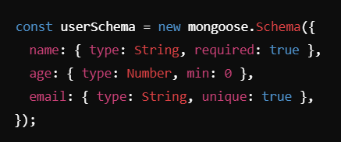

1. Validation:

Models allow you to validate data before saving it to the database.

This helps catch errors early and ensures that only valid data is stored.

Example:

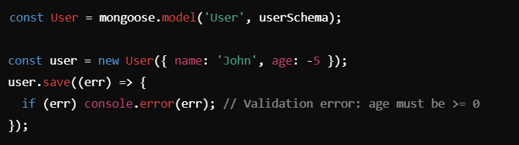

1. Middleware Support:

Mongoose models allow you to use middleware (hooks) for actions like pre-save, post-save, or pre-remove to perform additional logic.

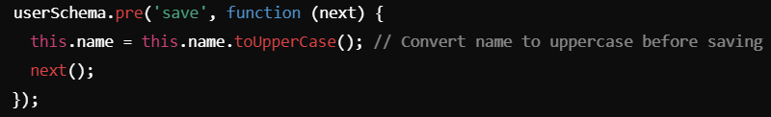

1. Built-in Methods:

Mongoose models come with built-in methods to simplify database operations, such as:

* find(): Fetch multiple documents.
* findOne(): Fetch a single document.
* create(): Insert a document.
* updateOne(), updateMany(): Update documents.
* deleteOne(), deleteMany(): Delete documents.

4.1) find query or select query with where condition where age is greater than equal to 18:

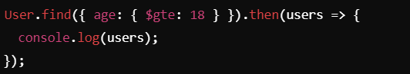

1. Custom Methods:

Models support adding custom methods (instance or static) for reusable operations.

* Instance Methods: Operate on a single document.
* Static Methods: Operate on the model itself.

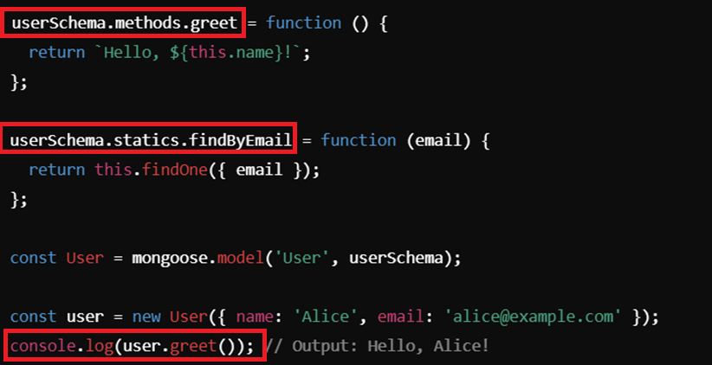

1. Relationships (References and Population):

* Mongoose models simplify working with related data by supporting references between collections (e.g., foreign keys).
* You can use populate() to fetch related data

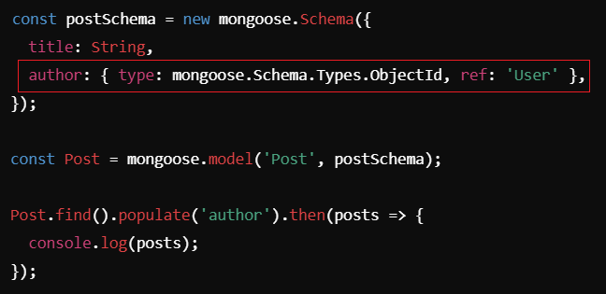

1. Indexing:

You can define indexes at the schema level to optimize queries and enforce constraints like uniqueness.

